Pluralsight:

1.**Approved PS verbs**: <https://docs.microsoft.com/en-us/powershell/scripting/developer/cmdlet/approved-verbs-for-windows-powershell-commands?view=powershell-7>

2.

1.Get-verb

2. get-verb -verb add | format-list

3. get-verb -group security | format-list

4. get-service -name M*

5. Get-alias(-Name, -Definition….)

get-alias -name gc*

get-alias -defination get-service

6. Get-help

7.Get-Command -- to find install command.

8.Get-member

9. $env:path | format-list

10. **Start-Transcript** -- >> Dubug tools where all stored regarding command lets.

11.Get-Member

-----**Trouble Shoot Ideas**:

12. get-command -Name get-Netfire*

13. Get-NetFirewallRule -Name *RemoteDeskTop* | Set-NetFirewallRule -Enabled 'True' -whatIf

----**Gathering Operating System Info**----------

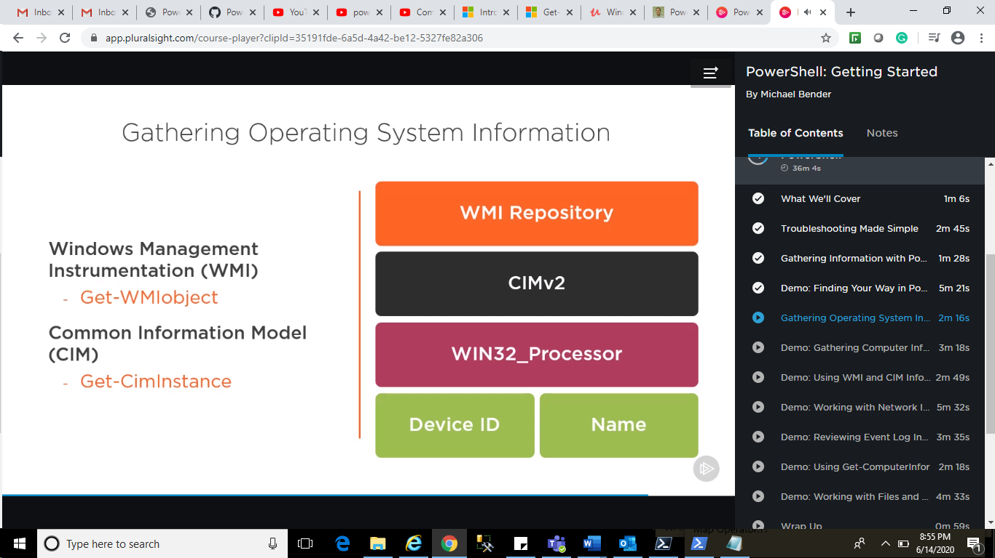

Get-Command *counter*

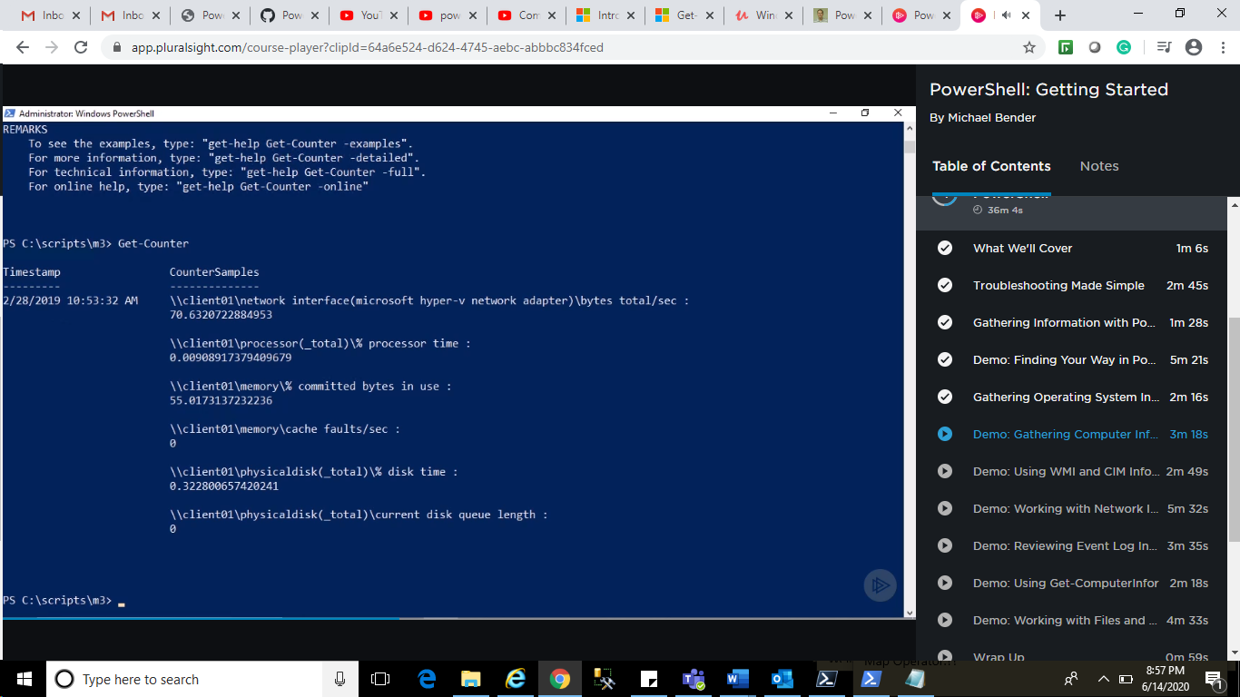

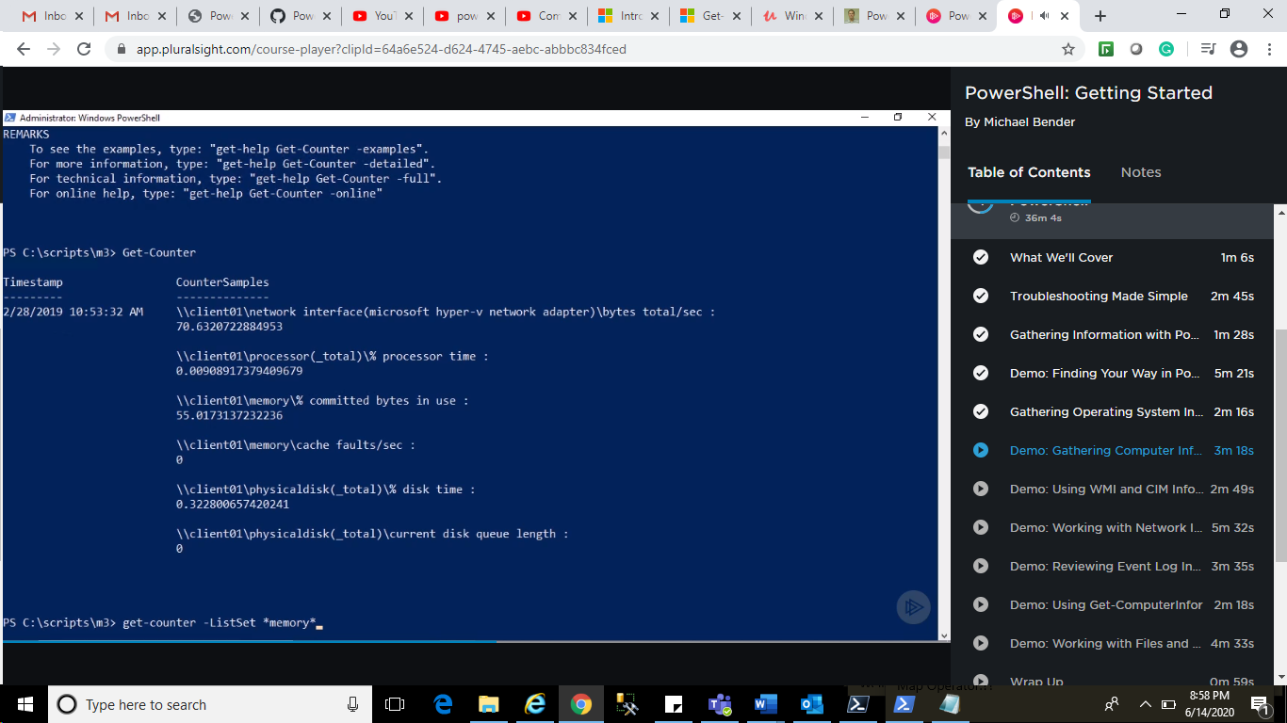

$MemCounters = (Get-Counter -ListSet Memory).Paths

Get-Counter -Counter $MemCounters

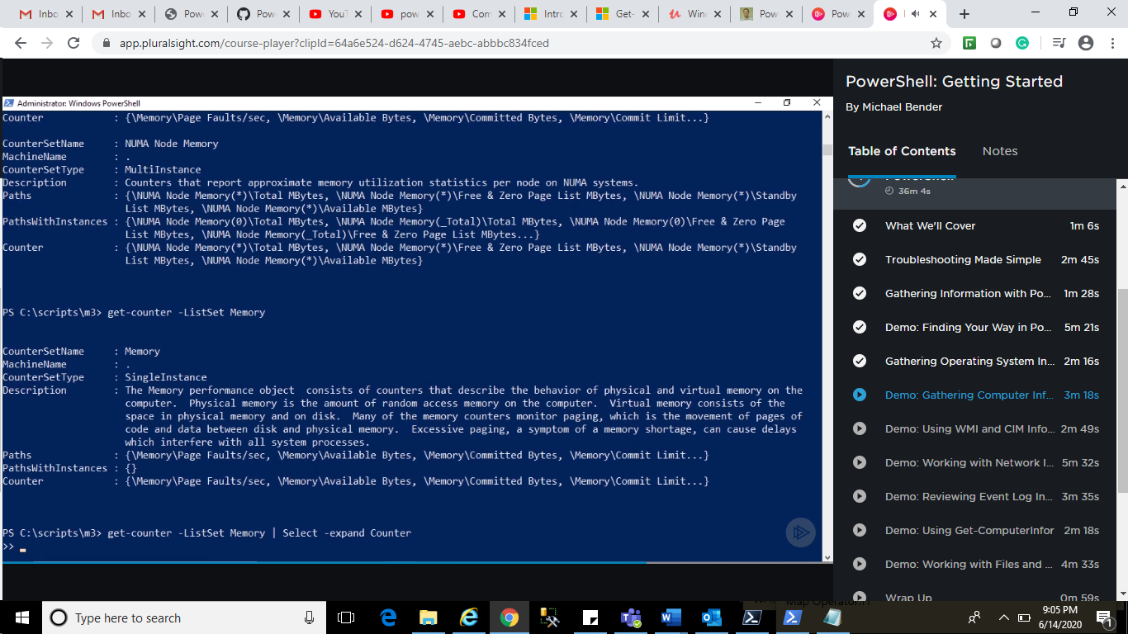

**Use WMI Object:**

Get-WMIObject -List *

Get-CMIClass -ClassName *

Get-CMIClass -className *memory*

Get-CimClass -className *memory* win32_physicalmemory

Get-cimInstance -className win32_physicalMemory | select Tag, Capacity

**Working with Network Issues:**

Ipconfig/All

Get-command Get-NetIP*

Get-NetIPAddress

Get-NetIPConfiguration

GCM get-DNSClient*

Get-DNSClient

Get-DnsClientCache

Get-DNSClientServerAddress

Get-Command *SMBMapping*

Help New-SmbMapping -example

New-SmpMapping -locapath w:remotepath \\DC01\Share

Get-smbmapping

**Checking Log Issue:**

**Get-command Get-*event\***

Get-eventlog -list

Get-eventLog -Logname System

Get-eventlog -log system -newest 1000 | where-object { $_.eventid -eq ‘1072’} Format-table machinename, username

**Get Computer Info:**

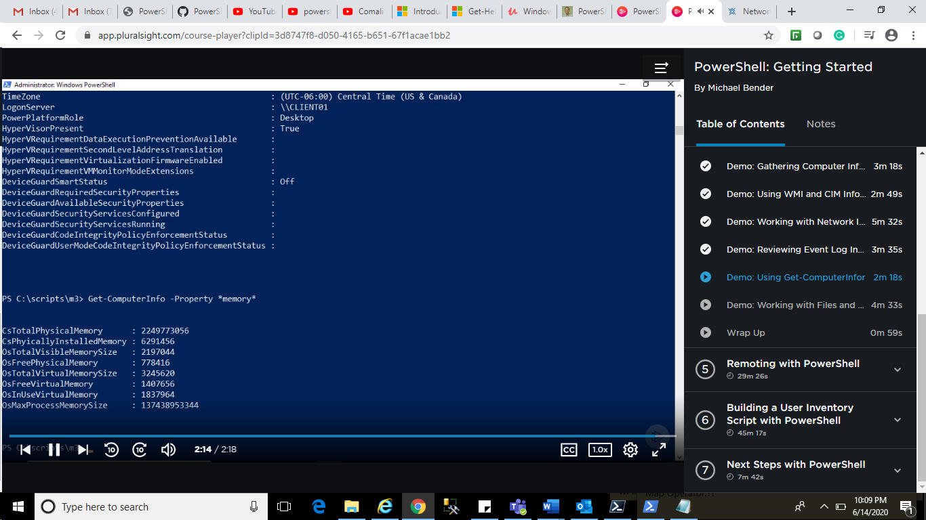

Working with Files and folder:

Get-childItem

GCI w:\ -Recurse | where Extension -EQ ‘.PNG’ | ft directory, Name, lastwriteTime

Copy-Item c:\copyfolder -destination c:\movefolder -verbose

**Remoting with PS:**

1.Winrm should enable both the machine to run command. Maintain connection.

2.Enable-PSRemoting -force - >on target computer.

3.Set-PSSessionConfiguration: - Name Microsoft.PowerShell -ShowSecurityDescriptorUI - >on Target Computer.

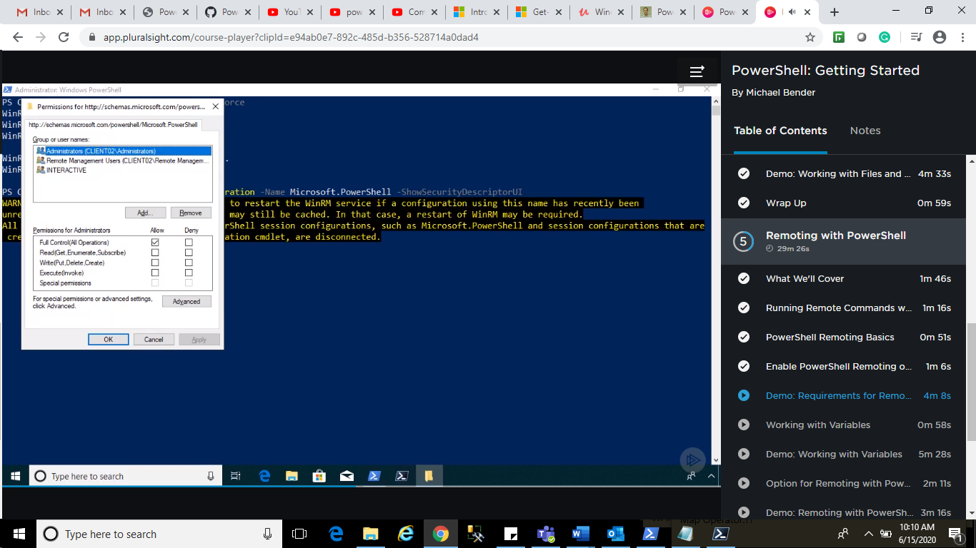

Building a User Inventory:

Bunch of script

.PS1

Move folder where script reside :

cd c:\scriptFolder

.\StoppedService.ps1

Note: enable Get-ExecutionPolicy -ExecutionPolicy RemoteSigned

.\StoppedService.ps1

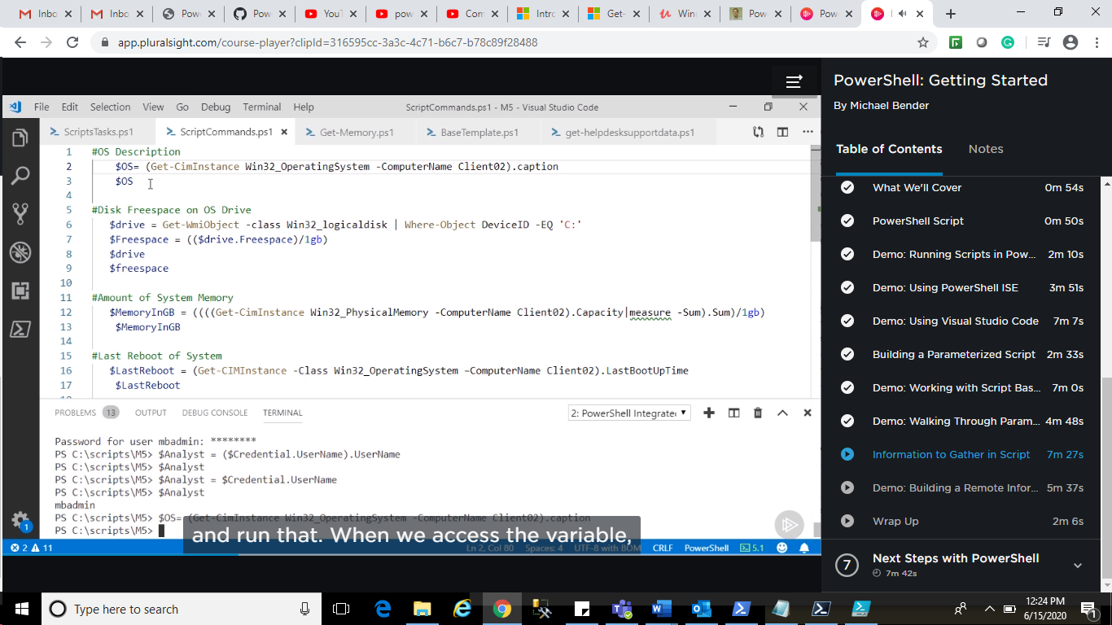

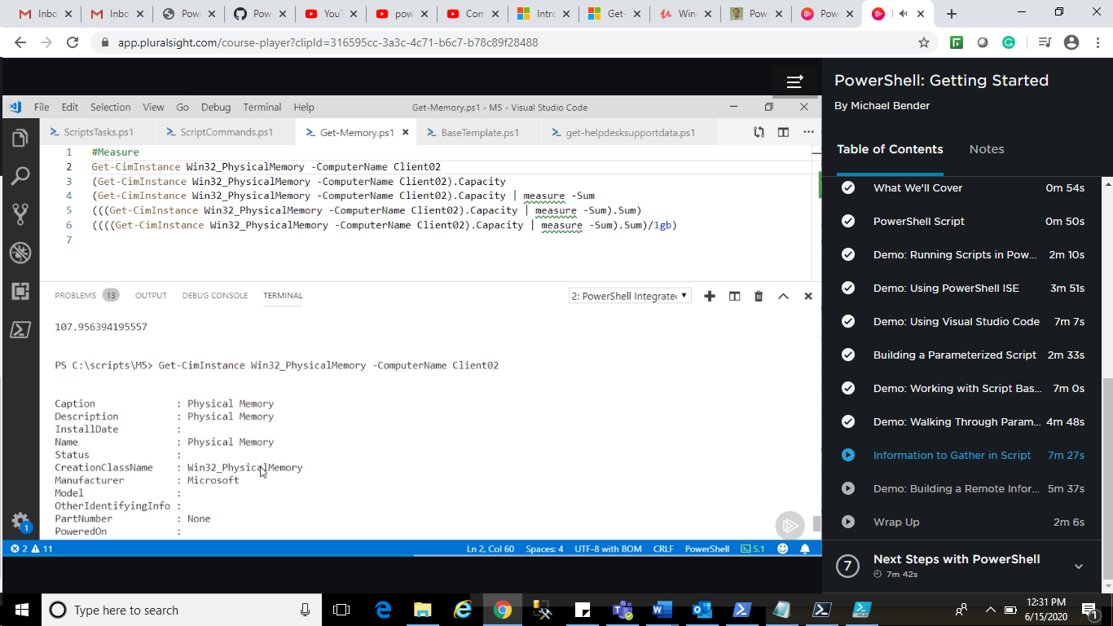

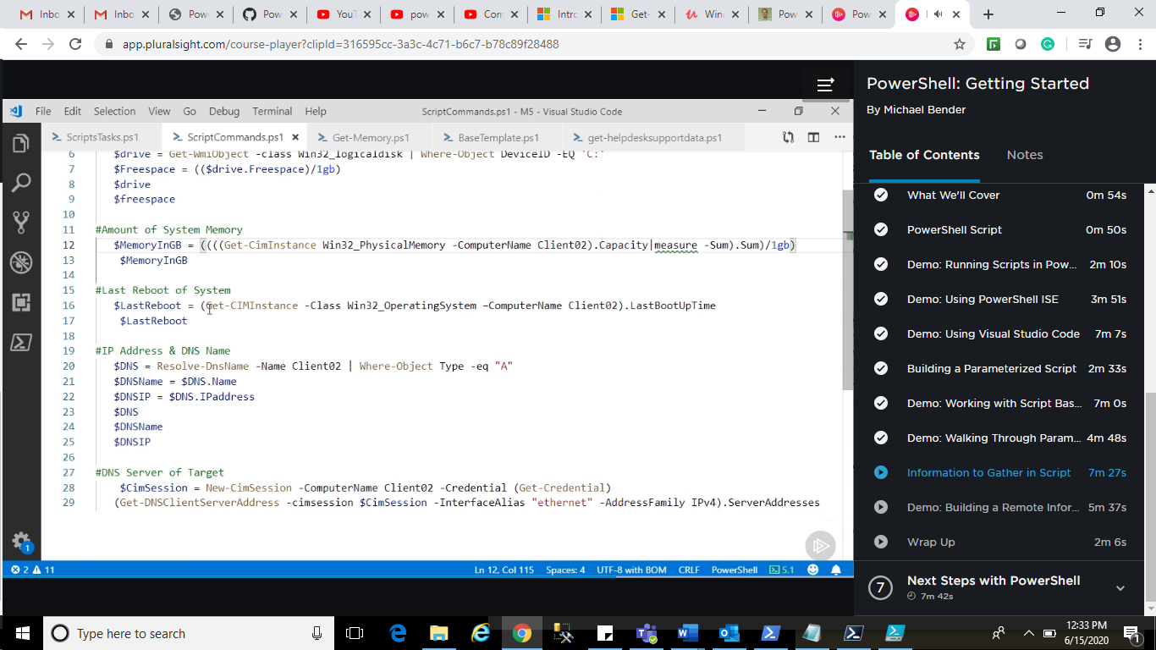

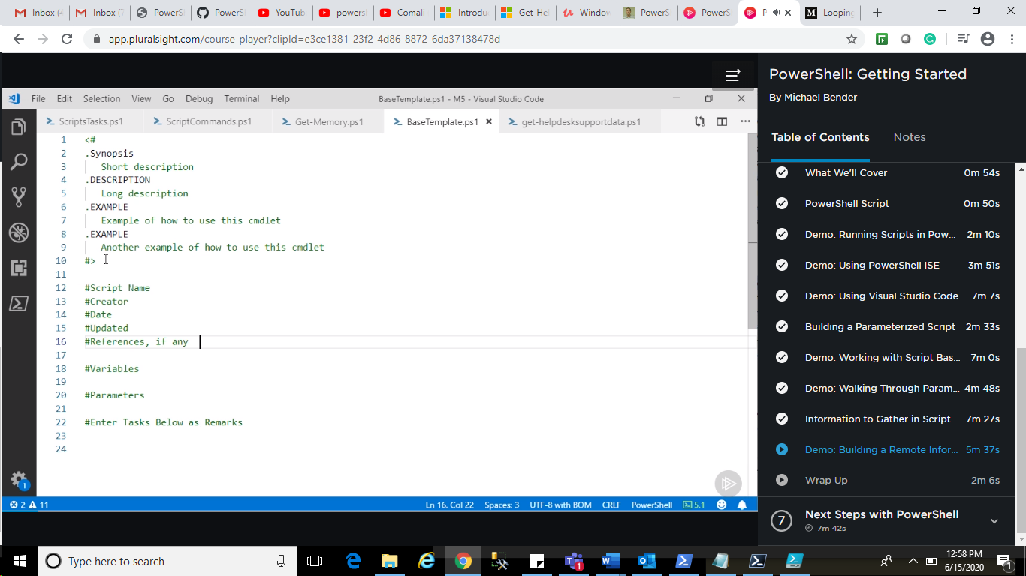

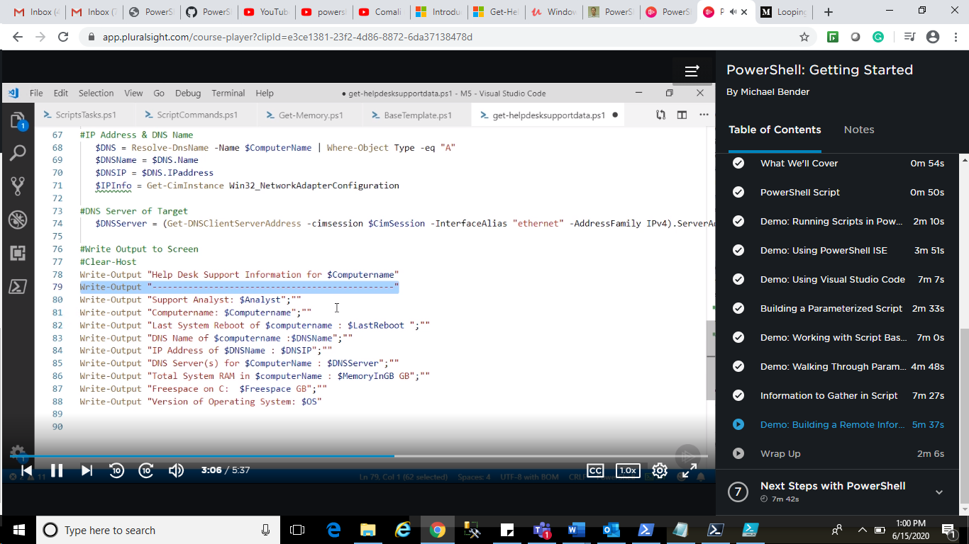

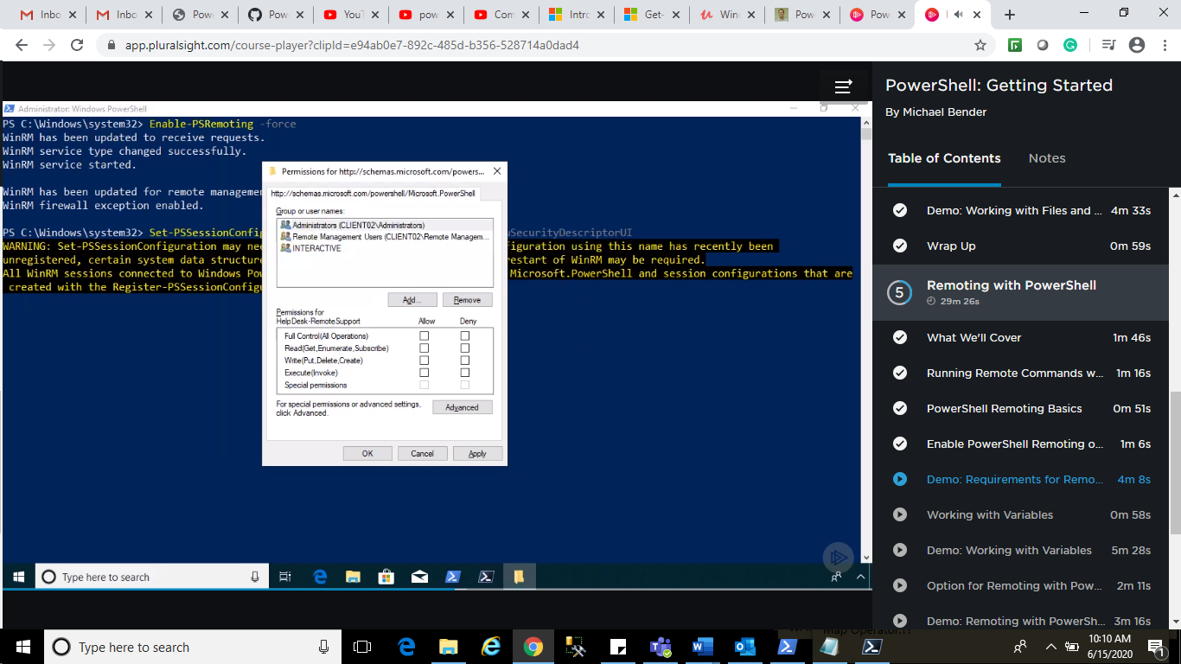

5. Enable Firewall:

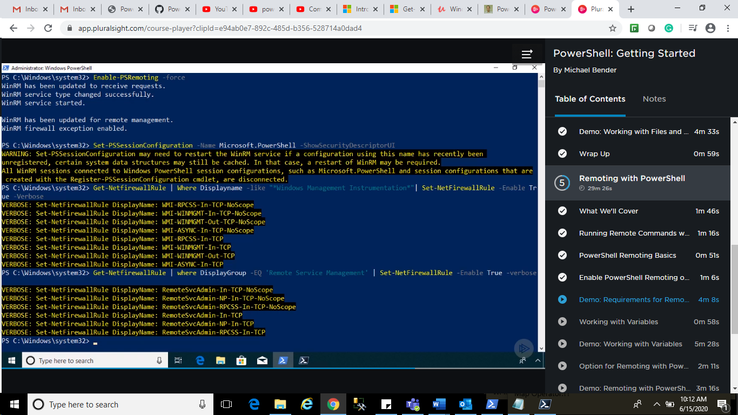

Now, Come to client Screens and do whatever you want.

Working with Varibale:

$env = GCI env: | More

$env:ComputerName

Option for Remoting:

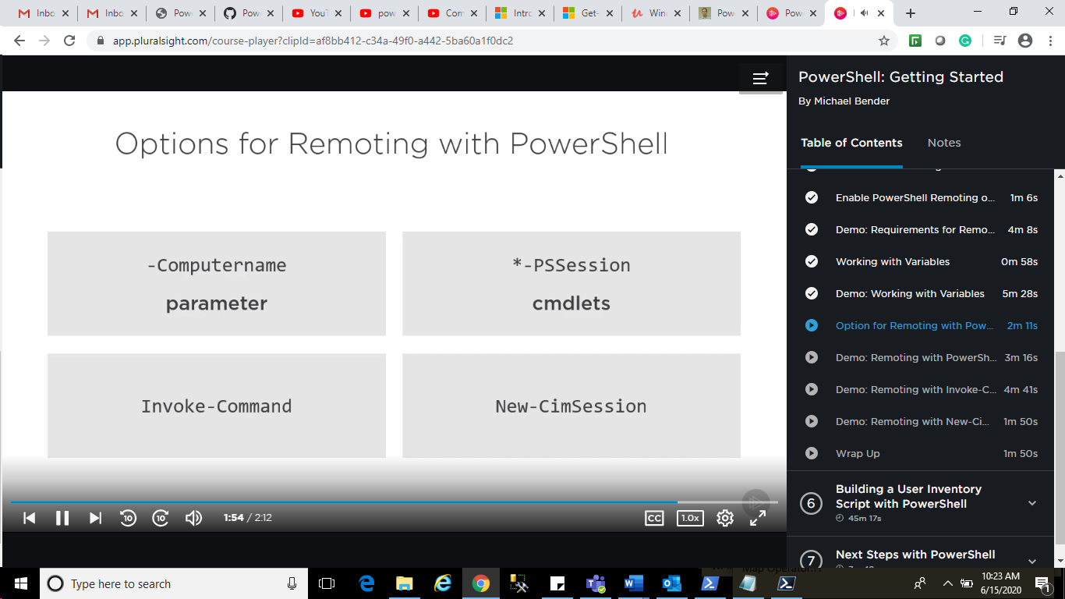

$ComputerName = “dc01”

GCM *-PSSession

$credential=Get-Credential

New-PSSession -ComputerName $ComputerName -Credential $ credential

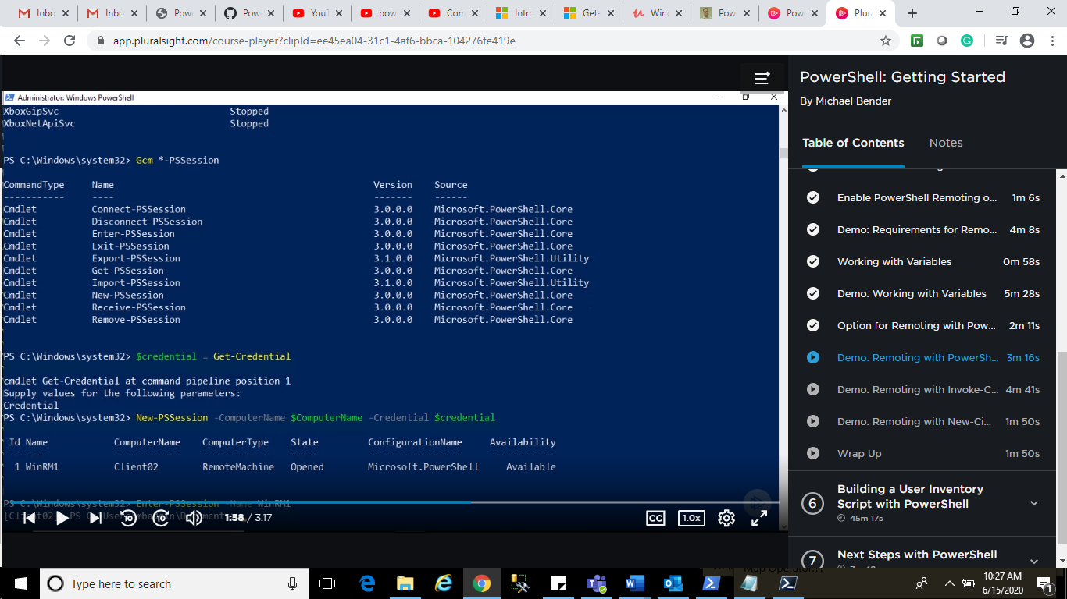

Enter-PSSession -Name WinRM1

$env:ComputerName

Exit

Get-PSSession

Remoting with Invoke Command:

$computerName= “aaa”

$cred = Get-Credential;

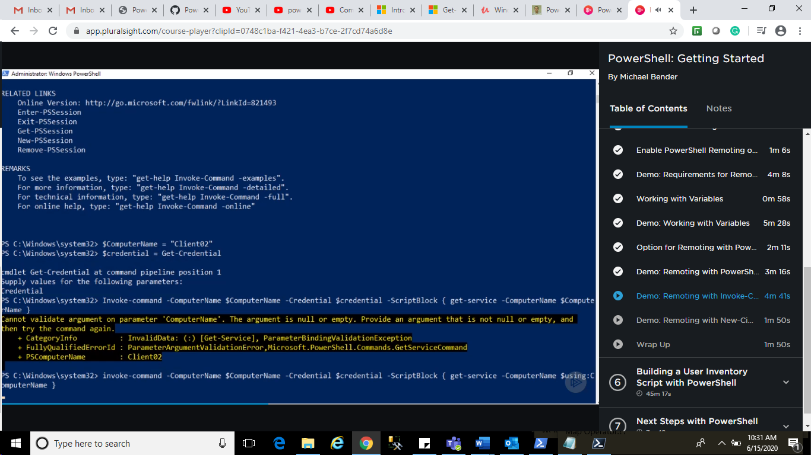

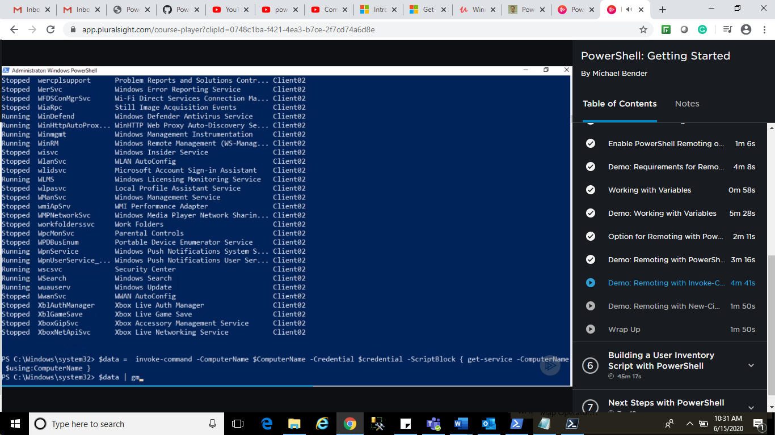

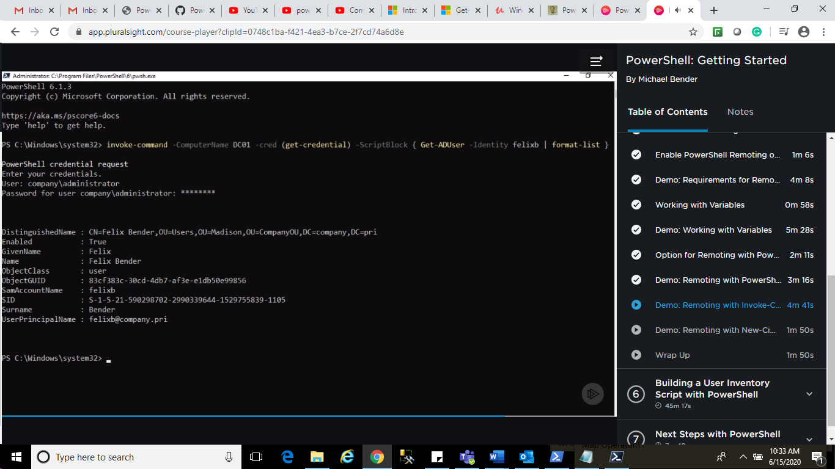

How to use New-CMI Session

